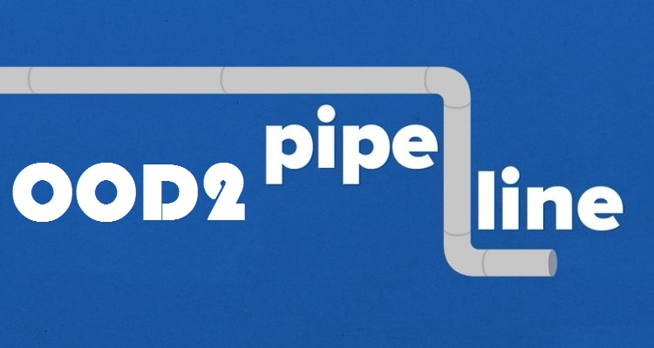

**Design document**

Date

12 - June - 2017.

OOD2 group

Team (names and student number)

Hoang Linh - 2233495

Fei Pei- 2585413

Simon Onumajuru - 2727897

Xiankuan Peng - 2624109

Status

Final version draft.

**INTRODUCTION**

**Introduction** **3**

**Class diagram:** **4**

**COMPONENT CLASS** **5**

MERGER CLASS 5

SINK CLASS 6

SPLITTER CLASS 6

ADJUSTABLE SPLITTER CLASS 7

PUMP CLASS 7

SAVELOAD CLASS 8

FLOWNETWORK CLASS 8

PIPELINE CLASS 9

**Sequence diagram:**

SaveToFile **11**

Add PipeLIne 12

Remove Component 13

# 

# 

# 

# 

# 

# 

# Introduction

This is a pipeline project to deliver an application where user can create his/ her own pipeline system and makes use of it. The application is called “Pipelines Simulator”, it provides possibilities for user to create and figure out the most efficient pipeline system to be used.

# Class diagram:

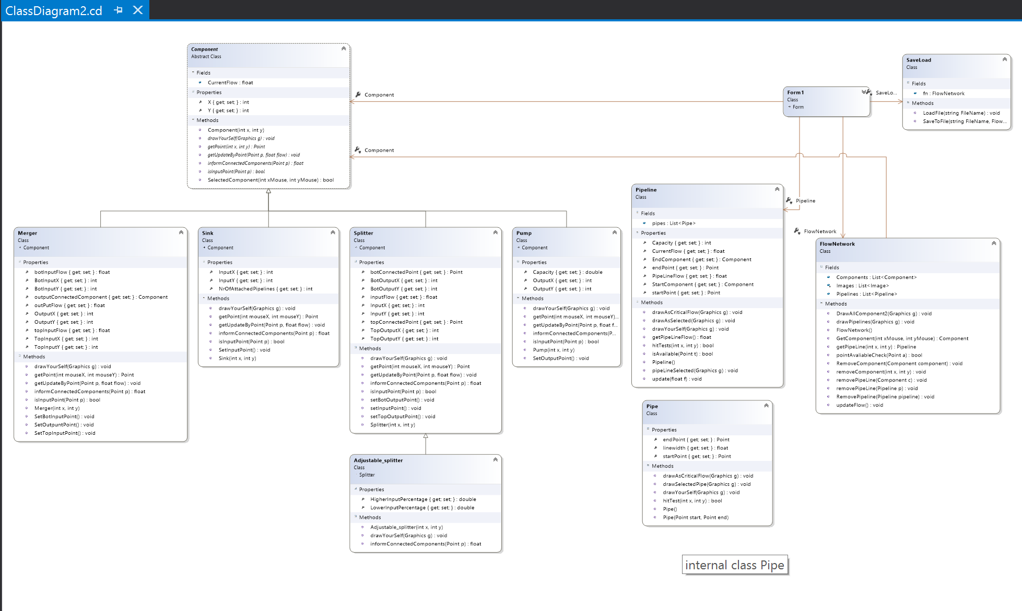

# **COMPONENT CLASS**

**Constructors:**

|  |  |
| --- | --- |
| **Name** | **Description** |
| Component(x,y) | Initializing new instance of the component class |

**Field:**

|  |  |
| --- | --- |
| **Name** | **Description** |
| CurrentFlow | A field variable for the current flow |

**Properties:**

|  |  |
| --- | --- |
| **Name** | **Description** |
| X: int | X coordinates for the component |
| Y: int | Y coordinates for the component |

**Methods:**

|  |  |
| --- | --- |
| **Name** | **Description** |
| drawYourSelf(Graphich g): void | Drawable abstract method which allows each components to draw itself |
| SelectedComponent(x,y): bool | Returns true if user clicks on a drawn component(This is used in the method getComponent() in the FlowNetwork to select the component. |
| getPoint(x,y) : Point | Abstract method, return a point based on x,y and subclass. |
| isInputPoint(Point p): bool | Abstract method, return true if point p is on the left side of the component |
| informConnectedComponents(Point p): float | //dead end, not implemented |
| getUpdateByPoint(Point p, Float flow): Void | Abstract method,inputFlow will be assigned with the value of float flow depends on the position of point p |

### 

### 

### 

### 

### 

### **MERGER CLASS**

**Constructors:**

|  |  |
| --- | --- |
| **Name** | **Description** |
| Merger() | Initializing new instance of the merger class |

**Properties:**

|  |  |
| --- | --- |
| **Name** | **Description** |
| TopInputX | X coordinate of the Top layer of merger. |
| TopInputY | Y coordinate of the Top layer of merger. |
| OutputX | X coordinate of Output pipeline for merger |
| OutputY | Y coordinate of Output pipeline for merger |
| topInputFlow | Stores the top input flow for the merger |
| botInputFlow | Stores the bottom input flow for the merger |
| outPutFlow | Stores the output flow for the merger |
| BotInputX | X coordinate of the Bottom layer of merger. |
| BotInputY | Y coordinate of the Bottom layer of merger. |

**Methods:**

|  |  |
| --- | --- |
| **Name** | **Description** |
| SetTopInputPoint(): void | Connects and sets the top input point |
| SetBotInputPoint(): void | Connects and sets the bottom input point |
| SetOutputPoint(): void | Sets output points to connect |
| getPoint(x,y) | retrieves the point position clicked on the canvas , return topInput point,botInputPoint or outPutPoint depends on x and y. |
| isInputPoint(Point p) | Return true if point p is in the left of the component |
| informConnectedComponents(Point p) | //dead end, not implemented |
| getUpdateByPoint(Point p, Float flow) | Assigned the value of flow to topInputFlow or botInputFlow depends on point p ‘s position |
| drawYourSelf(Graphich g): void | Allowing the class to draw itself |

### 

### **SINK CLASS**

**Constructors:**

|  |  |
| --- | --- |
| **Name** | **Description** |
| Sink() | Initializing new instance of the sink class |

**Properties:**

|  |  |
| --- | --- |
| **Name** | **Description** |
| InputX | X coordinate of the connected component |
| InputY | Y coordinate of the connected component |
| NrOfAttachedPipelines | The number of pipelines connected |

**Methods:**

|  |  |
| --- | --- |
| **Name** | **Description** |
| drawYourself(Graphich g): void | Allowing the class to draw itself |
| getUpdateByPoint(Point p, Float flow) | Always assign the current flow with the value of float flow |
| SetInputPoint(): void | Sets input points to draw pipeline |
| getPoint(x,y) | retrieves the point position clicked on the canvas ,always return a point with coordinate(inputX,inputY) |
| isInputPoint(Point p) | Always return true |
| informConnectedComponents(Point p) | //dead end, not implemented |

### **SPLITTER CLASS**

**Constructors:**

|  |  |
| --- | --- |
| **Name** | **Description** |
| Splitter() | Initializing new instance of the splitter class |

**Properties:**

|  |  |
| --- | --- |
| **Name** | **Description** |
| TopOutputX | X coordinate of the Top layer of merger. |
| TopOutputY | Y coordinate of the Top layer of merger. |
| InputX | Splitter’s input pipeline X coordinates |
| InputY | Splitter’s input pipeline Y coordinates |
| InputFlow | Y coordinate of the Bottom layer of merger. |
| BotOutputtX | X coordinate of the Bottom layer of merger. |
| BotOutputtY | Y coordinate of the Bottom layer of merger. |
| topConnectedPoint | Top connected point of the merger |
| botConnectedPoint | Bottom connected point of the merger |

**Methods:**

|  |  |
| --- | --- |
| **Name** | **Description** |
| SetInputPoint() | Sets the input point to draw pipeline |
| SetOutputPoint() | Sets the output point to draw pipeline |
| setBotOutputPoint() | Sets both output points to draw pipeline |
| GetFlow(p) | Gets the current flow of the splitter |
| drawYourself(Graphich g) | Allowing the component to draw itself |
| getPoint(x,y) | retrieves the point position clicked on the canvas ,return a point with coordinate of (inputX,inputY) or (botOutPutX,botOutPutY) or (topOutPutX,topOutPutY) depends on x,y |
| isInputPoint(Point p) | Return true if p is in the left of the component |
| informConnectedComponents(Point p) | //dead end, not implemented |
| getUpdateByPoint(Point p, Float flow) | Assigned the value of float flow to inputFlow |

### **ADJUSTABLE SPLITTER CLASS**

**Constructors:**

|  |  |
| --- | --- |
| **Name** | **Description** |
| AdjustableSplitter() | Initializing new instance of the adjustable splitter class |

**Properties:**

|  |  |
| --- | --- |
| **Name** | **Description** |
| UpperFlow | Determines the upper flow of the splitter |
| HigherInputPercentage | Percentage input for the top point |
| LowerInputPercentage | Percentage input for the bottom point |

**Methods:**

|  |  |
| --- | --- |
| **Name** | **Description** |
| drawYourself(Graphich g): void | Allowing the class to draw itself |
| informConnectedComponents(Point p) | Informs the connected components of the bottom input flow and top input flow |

### 

### **PUMP CLASS**

**Constructors:**

|  |  |
| --- | --- |
| **Name** | **Description** |
| Pump() | Initializing new instance of the pump class |

**Properties:**

|  |  |
| --- | --- |
| **Name** | **Description** |
| OutputX | X coordinate of the component connected to output port |
| OutputY | Y coordinate of the component connected to output port |
| Capacity | Capacity of the flow |

**Methods:**

|  |  |
| --- | --- |
| **Name** | **Description** |
| DrawYourself(Graphich g): void | Allowing the class to draw itself |
| SetOutputPoint() | Sets the output point to draw the pipe |
| getPoint(x,y) | retrieves the point position clicked on the canvas |
| isInputPoint(Point p) | Return false |
| informConnectedComponents(Point p) | //dead end, not implemented |
| getUpdateByPoint(Point p, Float flow) | throw new NotImplementedException(); |

### 

### **SAVELOAD CLASS**

**Methods:**

|  |  |
| --- | --- |
| **Name** | **Description** |
| LoadFile(Filename:string): void | Loading the project, This method loads a network by reading text file and creating new items of the network line by line. |
| SaveToFile(Filename:string, f: FlowNetwork): void | Saving the project, This method saves the entire network (which is found on the canvas- connected or not)  into a file by writing down each element |

### **FLOWNETWORK CLASS**

**Constructors:**

|  |  |
| --- | --- |
| **Name** | **Description** |
| FlowNetwork() | Initializing new instance of the FlowNetwork class |

**Properties:**

|  |  |
| --- | --- |
| **Name** | **Description** |
| Component: List | List of Components |
| Images: Images | List of Images loading all the components of the flow network |
| PipeLine: List | List of PipeLines |

**Methods:**

|  |  |
| --- | --- |
| **Name** | **Description** |
| getComponent(x,y): Component | returns a component that user clicked on, otherwise show warning to the user. |
| getPipeLine(x,y): PipeLine | returns a pipeline that user clicked on (by calculating the points which is a coordinate x and y to obtain the value) |
| DrawAllComponent2(Graphics g) | Each components draws itself separately |
| removeComponent(Component c): void | Removes a component |
| removePipeline(Pipeline p): void | //not implemented, |
| drawPipeLines(Graphic g): void | Loop through list pipelines, and call drawYourself on each pipeline |
| RemoveComponent(x,y) | Removes all associated pipelines of the component with coordinate(x,y), and then remove that component from the list. |
| pointAvaliableCheck(Point a) | Detects if there is an available point to connect , attached to components |
| removePipeline(Component c): void | Removes a pipeline associated to a component |
| updateFlow() | Updates the flow of the pipelines |

### **PIPELINE CLASS**

**Constructors:**

|  |  |
| --- | --- |
| **Name** | **Description** |
| PipeLine() | Initializing new instance of the PipeLine class |

**Properties:**

|  |  |
| --- | --- |
| **Name** | **Description** |
| isSelected |  |
| startPoint | Y coordinate of the first connected component |
| endPoint | X coordinate of the second connected component |
| Pipes: List<Pipe> | List of pipes |
| StartComponent: Component | First connected component |
| EndComponent: Component | Second connected component |
| CurrentFlow | has the current flow of the pipeline |

**Methods:**

|  |  |
| --- | --- |
| **Name** | **Description** |
| drawYourSelf(Graphics g) | Allowing the class to draw itself |
| drawAsSelected(Graphics g) | Foreach pipe in pipes, calling pipe’s drawAsSelected method |
| pipeLineSelected(Graphics g) | Draw all pipes in list pipes in black |
| isAvailable(Point t) | this will loop through all pipe in pipes, return true if point t is not used as a startpoint or an end point |
| hitTests(int x, int y) | call hitTest on each pipe in the pipes list,return false if any hitTest from pipe return false |
| getPipeLineFlow() | return the output flow from the source component. |
| update(float f) | update the end component's current with float f |

### 

### 

### **FORM CLASS**

**Method:**

|  |  |
| --- | --- |
| **Name** | **Description** |
| ExportToPNG | Exports the draw flow network into a PNG (picture) format |

### **PIPE CLASS (Extra Class)**

**Constructors:**

|  |  |
| --- | --- |
| **Name** | **Description** |
| Pipe(Point start, Point end) | Initializing new instance of the pump class |

**Properties:**

|  |  |
| --- | --- |
| **Name** | **Description** |
| startPoint | Store start point |
| endPoint | Store end point |
| linewidth | Indicates the detection distance between a point and the pipe(its a line) |

**Methods:**

|  |  |
| --- | --- |
| **Name** | **Description** |
| drawYourSelf(Graphics g) | Allowing the class to draw itself |
| drawAsSelectedPipe(Graphics g) | Allowing the class to draw the pipe |
| hitTest(x,y) | Calculate the distance between the point(x,y) and the pipe, return true if its smaller than linewidth/2 |

### 

### **FORM PROPERTIES (Extra class)**

**Method:**

|  |  |
| --- | --- |
| **Name** | **Description** |
| selectedComponent | Component that user currently selected |
| selectedPipeline | Pipeline that user currently selected |
| tempPoint | Store the latest point when creating a pipe |
| tempPipe | An empty/unfinished pipe. |
| tempPipeline | An empty/unfinished pipeline |

# 

# Sequence diagram:

SaveToFile: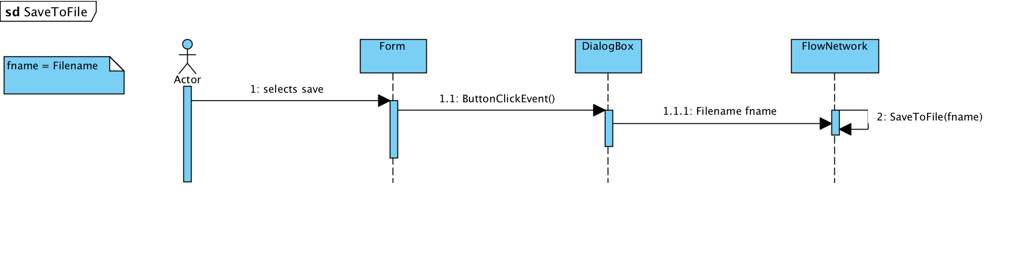

Add PipeLine: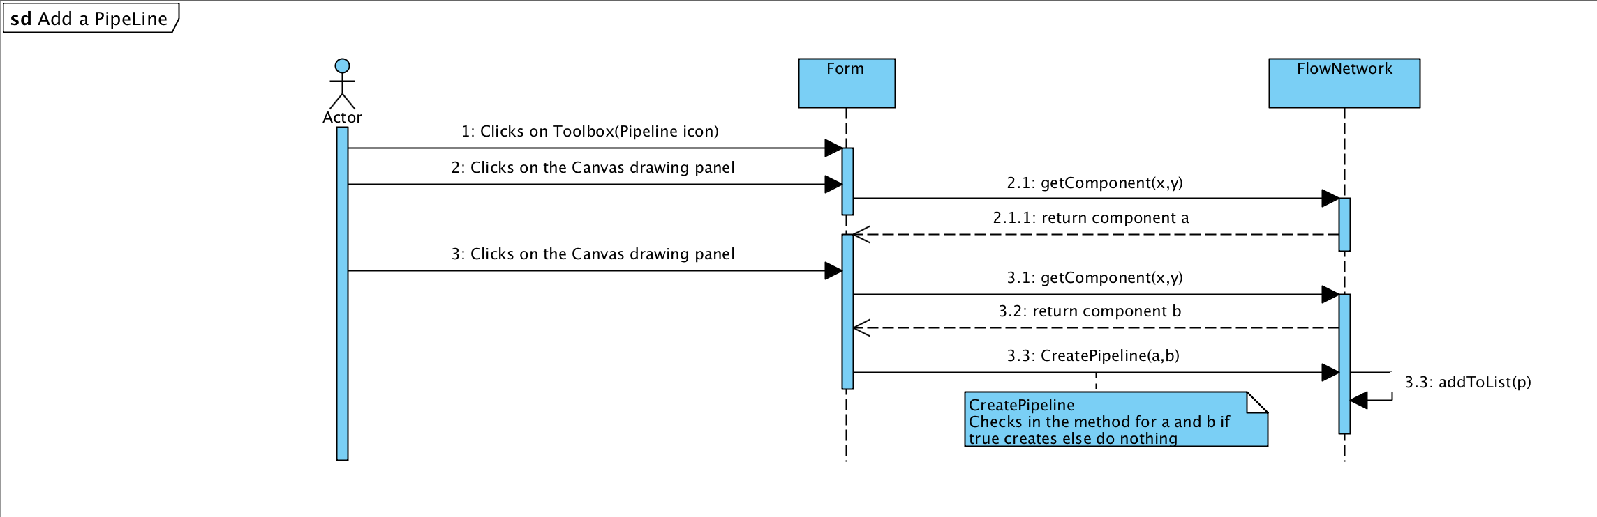

Remove Component:

